Opposite Rays
# Source: AI Source: Provided by: [Data Path: Persons Table -> ID Column: 1, Name_En Column: Motasem Essam] -> From: [ChatGPT] on [7/25/2026]
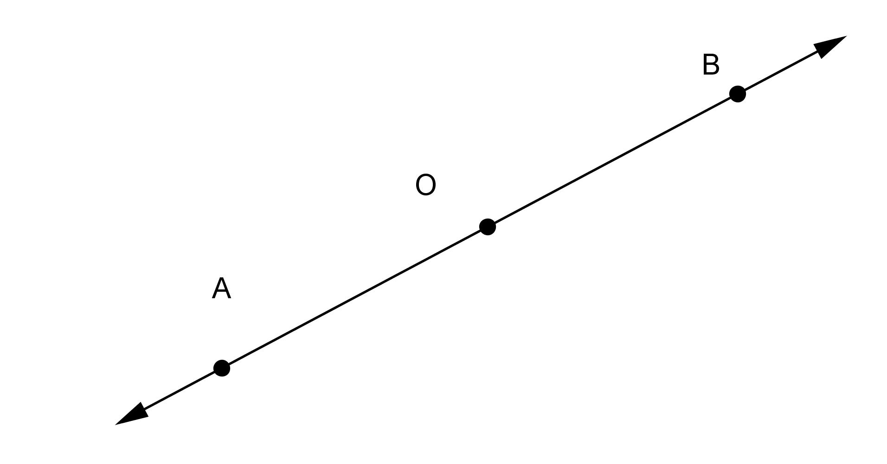
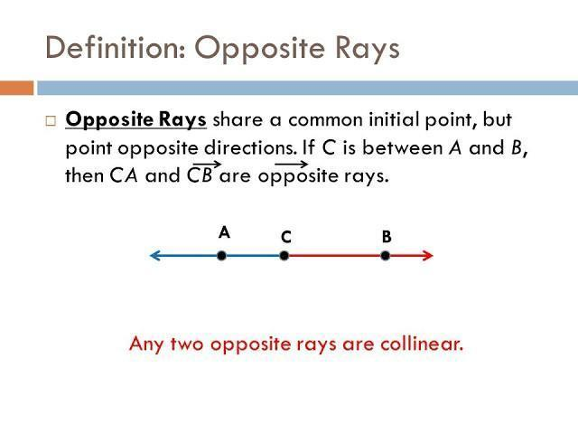
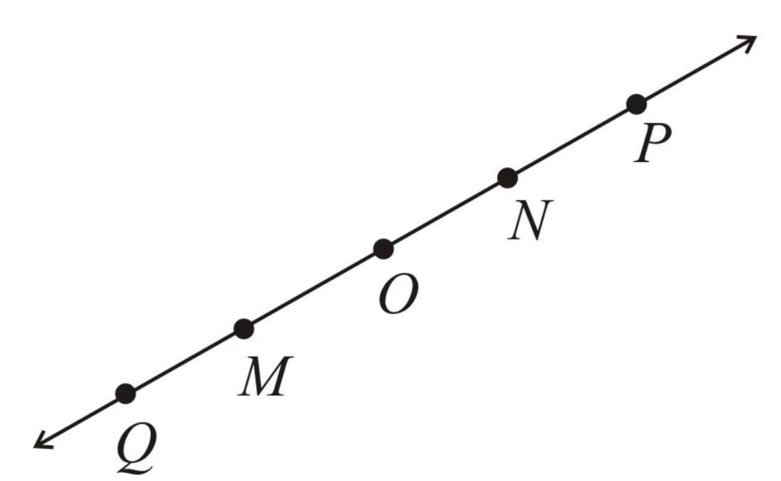
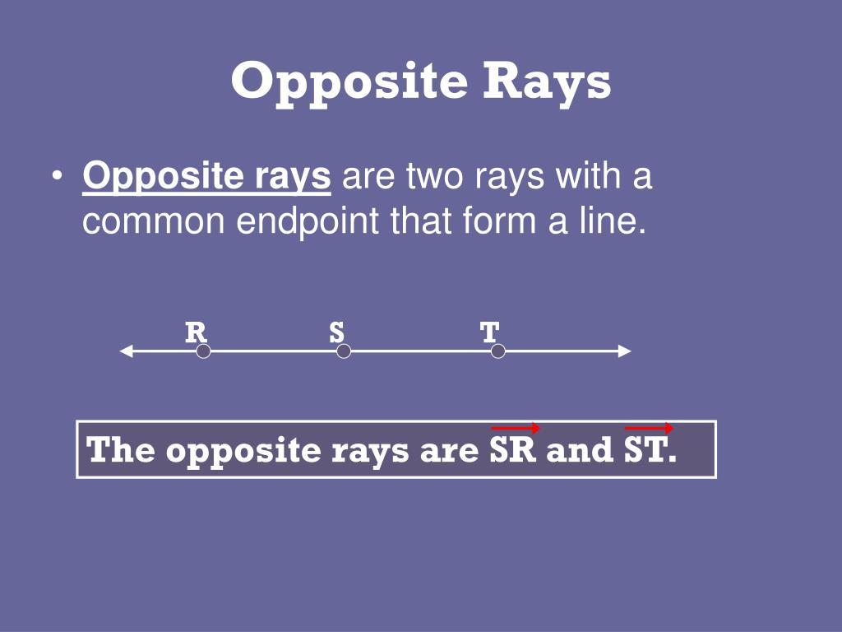
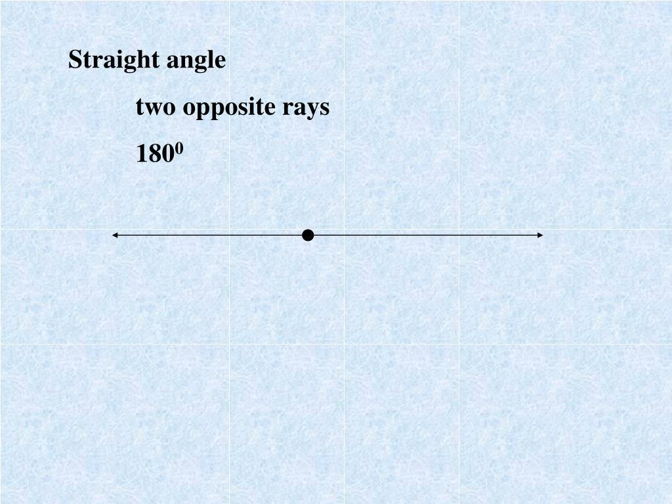

Definition
# Source: AI Source: Provided by: [Data Path: Persons Table -> ID Column: 1, Name_En Column: Motasem Essam] -> From: [ChatGPT] on [7/25/2026]
Opposite Rays are two rays that share the same endpoint and extend infinitely in exactly opposite directions along the same straight line.
Together, opposite rays form a straight line.

Characteristics
# Source: AI Source: Provided by: [Data Path: Persons Table -> ID Column: 1, Name_En Column: Motasem Essam] -> From: [ChatGPT] on [7/25/2026]
Opposite rays:
- Share one common endpoint.
- Extend infinitely in opposite directions.
- Are collinear (lie on the same straight line).
- Form a straight angle of:
$${180}^{∘}$$
- Together make one complete straight line.

Illustration
# Source: AI Source: Provided by: [Data Path: Persons Table -> ID Column: 1, Name_En Column: Motasem Essam] -> From: [ChatGPT] on [7/25/2026]
←────────●────────→
O
The rays begin at the common endpoint O and extend in opposite directions.

Mathematical Representation
# Source: AI Source: Provided by: [Data Path: Persons Table -> ID Column: 1, Name_En Column: Motasem Essam] -> From: [ChatGPT] on [7/25/2026]
If two rays
$$\vec{OA}$$
and
$$\vec{OB}$$
share endpoint
$$O$$
and point in opposite directions on the same line, then they are opposite rays.

Coordinate Geometry
# Source: AI Source: Provided by: [Data Path: Persons Table -> ID Column: 1, Name_En Column: Motasem Essam] -> From: [ChatGPT] on [7/25/2026]
Suppose the common endpoint is
$$O\left(0 , 0\right)$$
One ray passes through
$$A\left(4 , 0\right)$$
and extends to the right.
The opposite ray passes through
$$B\left(- , 40\right)$$
and extends to the left.
The two rays are opposite because they:
- share endpoint $O$,
- are collinear,
- extend in opposite directions.

Straight Angle
Opposite rays always form a straight angle.
$${180}^{∘}$$

Examples
# Source: AI Source: Provided by: [Data Path: Persons Table -> ID Column: 1, Name_En Column: Motasem Essam] -> From: [ChatGPT] on [7/25/2026]
Examples of opposite rays include:
- The positive and negative directions of the x-axis.
- The positive and negative directions of the y-axis.
- A straight road extending in opposite directions from an intersection.
- A number line extending left and right from zero.
- A straight beam extending from a central joint.

Properties
# Source: AI Source: Provided by: [Data Path: Persons Table -> ID Column: 1, Name_En Column: Motasem Essam] -> From: [ChatGPT] on [7/25/2026]
Opposite rays:
- Share one endpoint.
- Are collinear.
- Extend infinitely in opposite directions.
- Form exactly one straight line.
- Form a straight angle of:
$${180}^{∘}$$

Applications
# Source: AI Source: Provided by: [Data Path: Persons Table -> ID Column: 1, Name_En Column: Motasem Essam] -> From: [ChatGPT] on [7/25/2026]
Opposite rays are used in:
- Plane Geometry
- Coordinate Geometry
- Angle Measurement
- Engineering
- Architecture
- Construction
- CAD (Computer-Aided Design)
- Technical Drawing
- Surveying
- Computer Graphics

Advantages
# Source: AI Source: Provided by: [Data Path: Persons Table -> ID Column: 1, Name_En Column: Motasem Essam] -> From: [ChatGPT] on [7/25/2026]
Studying opposite rays helps to:
- Understand straight angles.
- Analyze angle relationships.
- Construct geometric figures.
- Develop coordinate geometry skills.
- Interpret directional systems.

Limitations
# Source: AI Source: Provided by: [Data Path: Persons Table -> ID Column: 1, Name_En Column: Motasem Essam] -> From: [ChatGPT] on [7/25/2026]
Opposite rays:
- Must share the same endpoint.
- Must lie on the same straight line.
- Must extend in exactly opposite directions.

Comparison with Related Objects
# Source: AI Source: Provided by: [Data Path: Persons Table -> ID Column: 1, Name_En Column: Motasem Essam] -> From: [ChatGPT] on [7/25/2026]
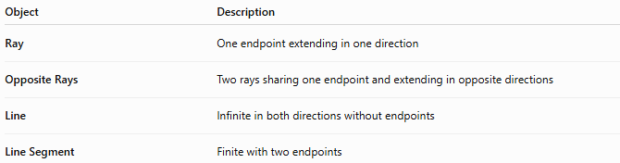
Object | Description
Ray | One endpoint extending in one direction
Opposite Rays | Two rays sharing one endpoint and extending in opposite directions
Line | Infinite in both directions without endpoints
Line Segment | Finite with two endpoints

Key Points
# Source: AI Source: Provided by: [Data Path: Persons Table -> ID Column: 1, Name_En Column: Motasem Essam] -> From: [ChatGPT] on [7/25/2026]
- Opposite Rays share one endpoint.
- They extend infinitely in opposite directions.
- They are collinear.
- Together they form a straight line.
- They always create an angle of:
$${180}^{∘}$$
- Opposite rays are fundamental in geometry, engineering, architecture, surveying, CAD, and technical drawing.

Conclusion
# Source: AI Source: Provided by: [Data Path: Persons Table -> ID Column: 1, Name_En Column: Motasem Essam] -> From: [ChatGPT] on [7/25/2026]
Opposite Rays are two rays that originate from the same endpoint and extend infinitely in opposite directions along a single straight line. Because they are collinear and point away from each other, they always form a straight angle of ${180}^{∘}$and together represent a complete straight line. Opposite rays are fundamental in plane geometry, coordinate geometry, angle measurement, engineering, architecture, construction, surveying, CAD, technical drawing, and computer graphics, where they are essential for defining straight angles, reference directions, and linear geometric relationships.

